LAB 03 Tasks (C Language)

Name: Muhammad Sarim Abidi

Section: BAI-1A

Roll No: 25K-0090

GitHub Link: [PF_Lab Tasks](https://github.com/K250090-MuhammadSarimAbidi/PF_Lab)

Question 1

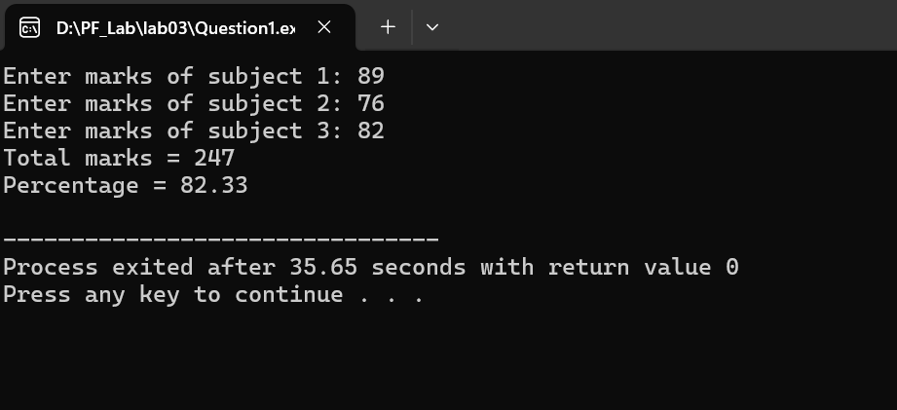

Question 2

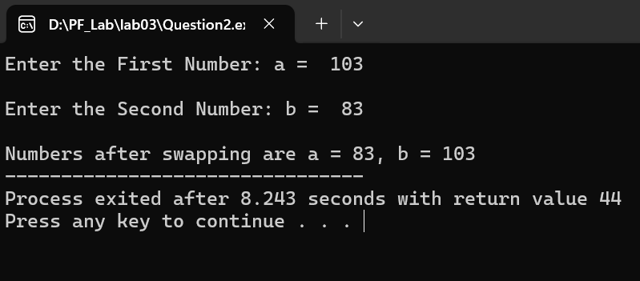

Question 3

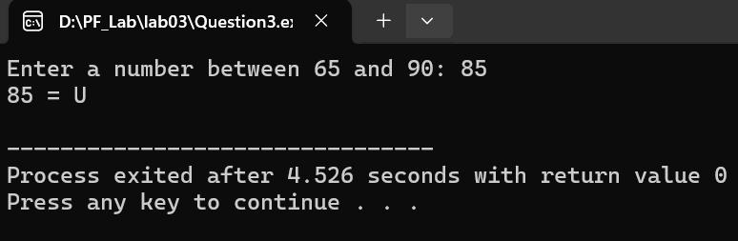

Question 4

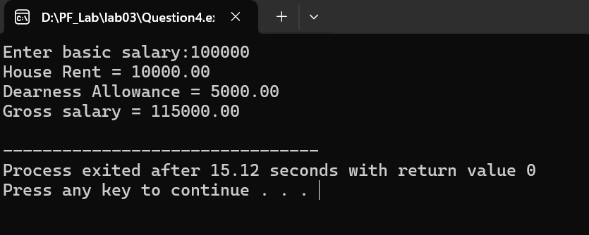

Question 5

